**Software Project Management Lab 4 Report**

**Student: Trần Quốc Việt – 1953097 – Class CC01**

1. **Set Baseline for the project**

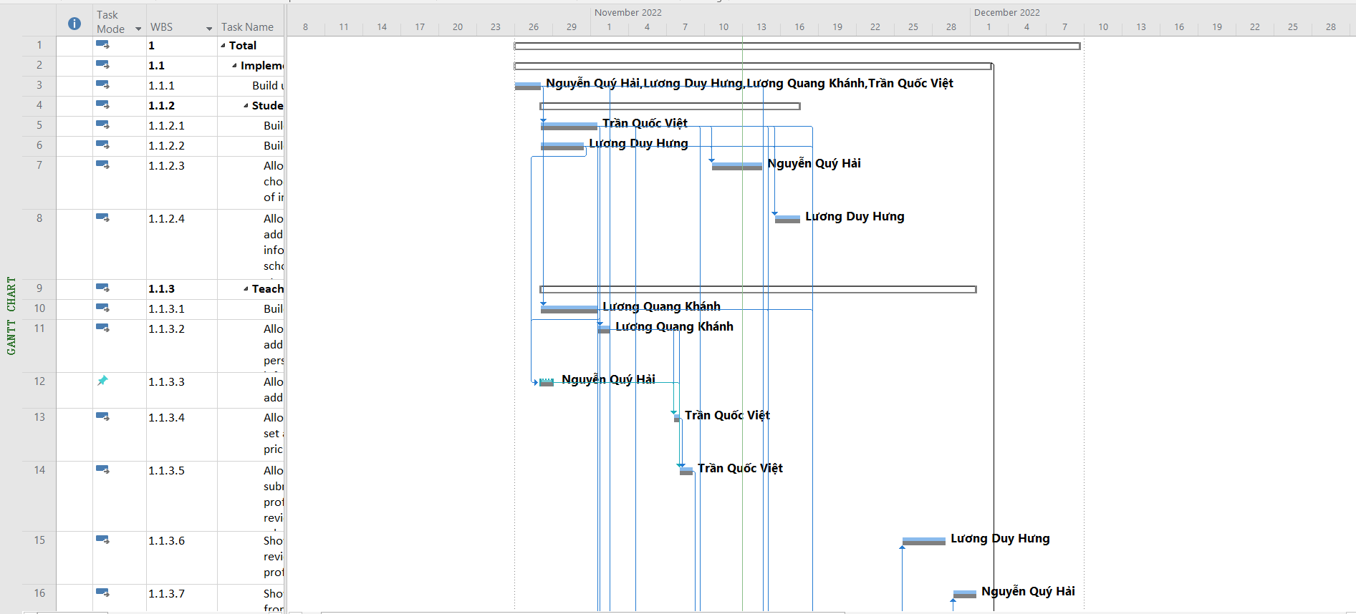

1. **Comparing the baseline and actual plan**

Suppose that we increased the duration of the task “Build user DB” from 16 hours to 24 hours. We can see that the actual schedule of the task has exceeded the baseline, along with overallocated resources problems.

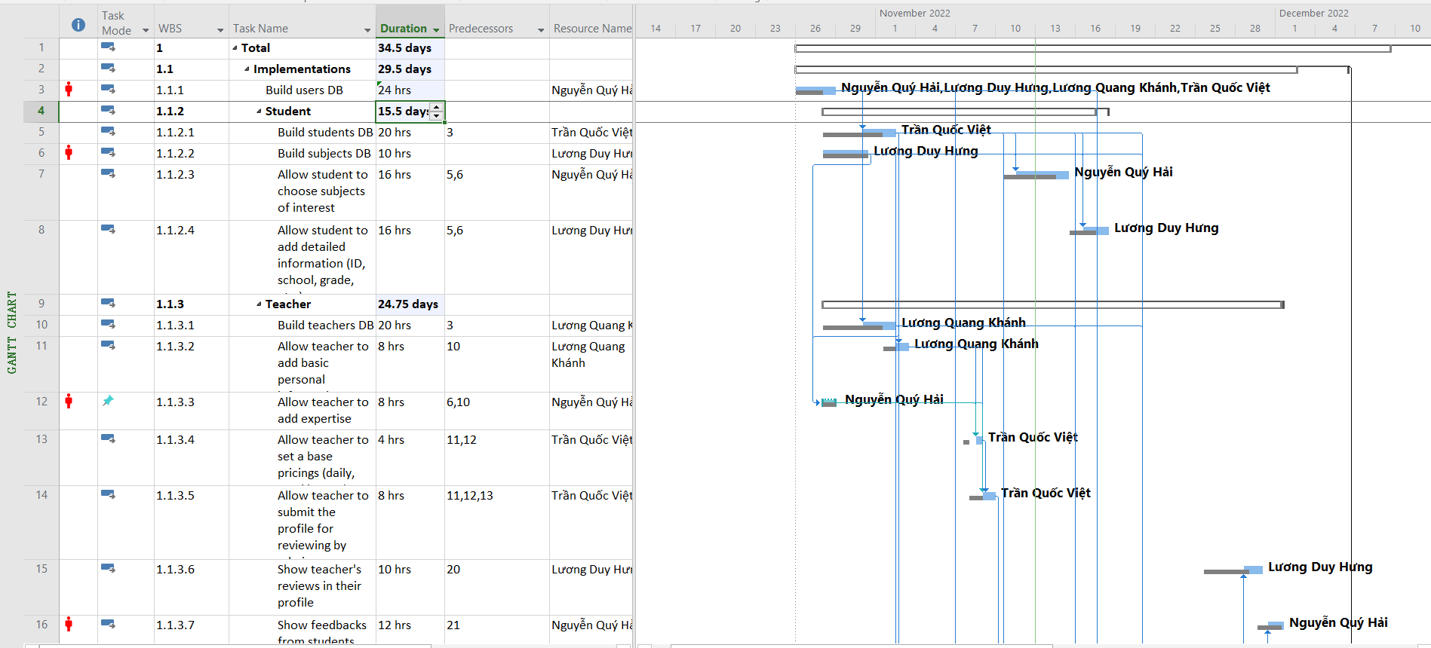

1. **Project control based on baseline and actual schedule and cost**

After automatically rescheduling the tasks, the Gantt chart view looks like below. Statistically, the project is **5 days after the schedule** and the cost rises from **$13,880 to $14,520**. This extra cost in time and resources is reasonable, hence it will be accepted.

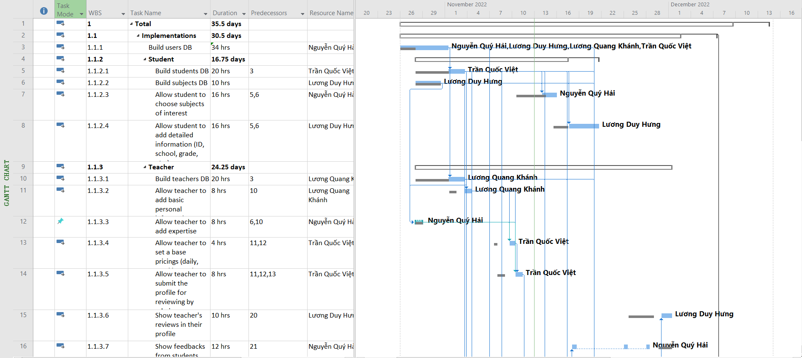

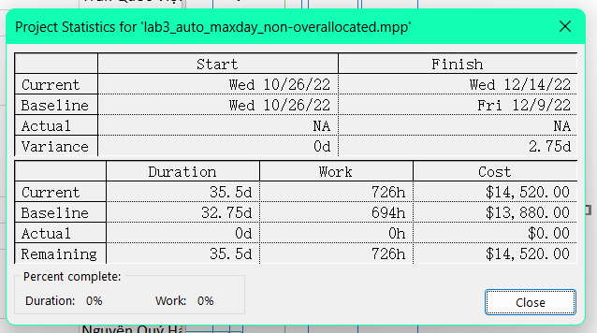

1. **Project overview report**

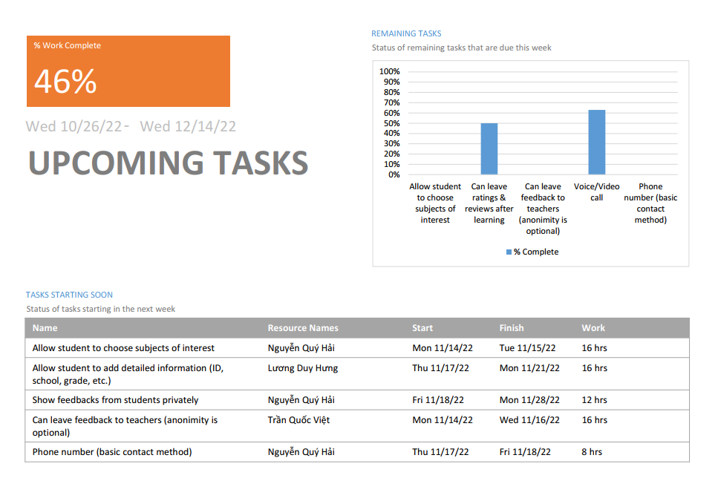

1. **Actual project progress evaluation**

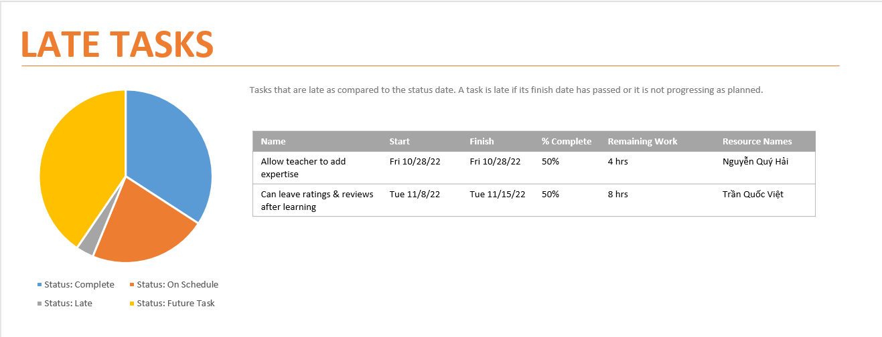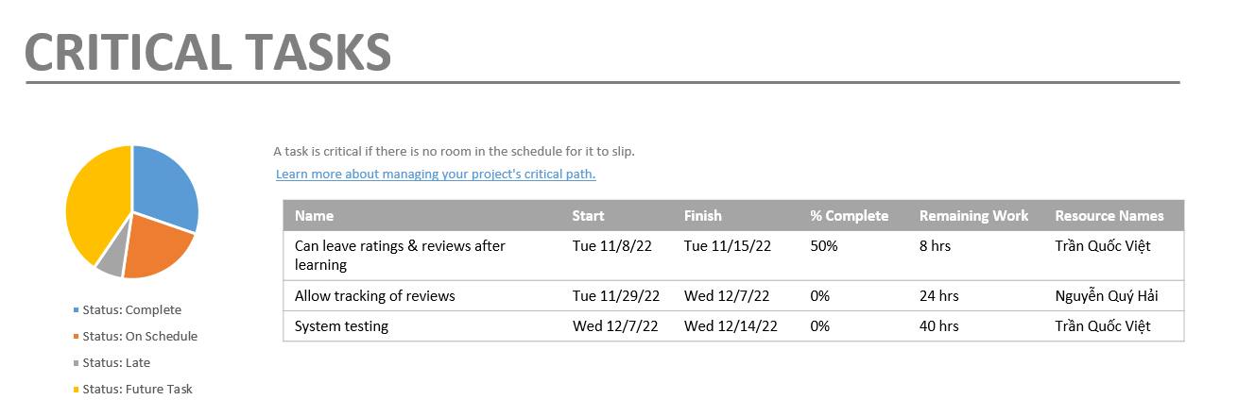



1. **Some problems related to the developer team, customers, or human resources change happens that would affect the project schedule.**

|  |  |  |
| --- | --- | --- |
| **Name** | **Probability** | **Effect** |
| The customer changes requirements | Medium | Can be tolerable or serious |
| Server crashes | Low | Tolerable |
| A developer has a predetermined absence | High | Moderate |
| A developer has a sudden absence | Medium | Serious |
| Personal Shortfalls for a task | Low | Moderate |
| Development technical too difficult | Medium | Significant |
| Developer uncertain of customer’s requirement | Medium | Serious |